Project Design Phase-II
Technology Stack (Architecture & Stack)

Date | 25 June 2025
Team ID | LTVIP2025TMID20750
Project Name | Visualizing Housing Market Trends: An Analysis Of Sale Prices and Features Using Tableau
Maximum Marks | 4 Marks

Technical Architecture:
The Deliverable shall include the architectural diagram as below and the information as per the table1 & table 2
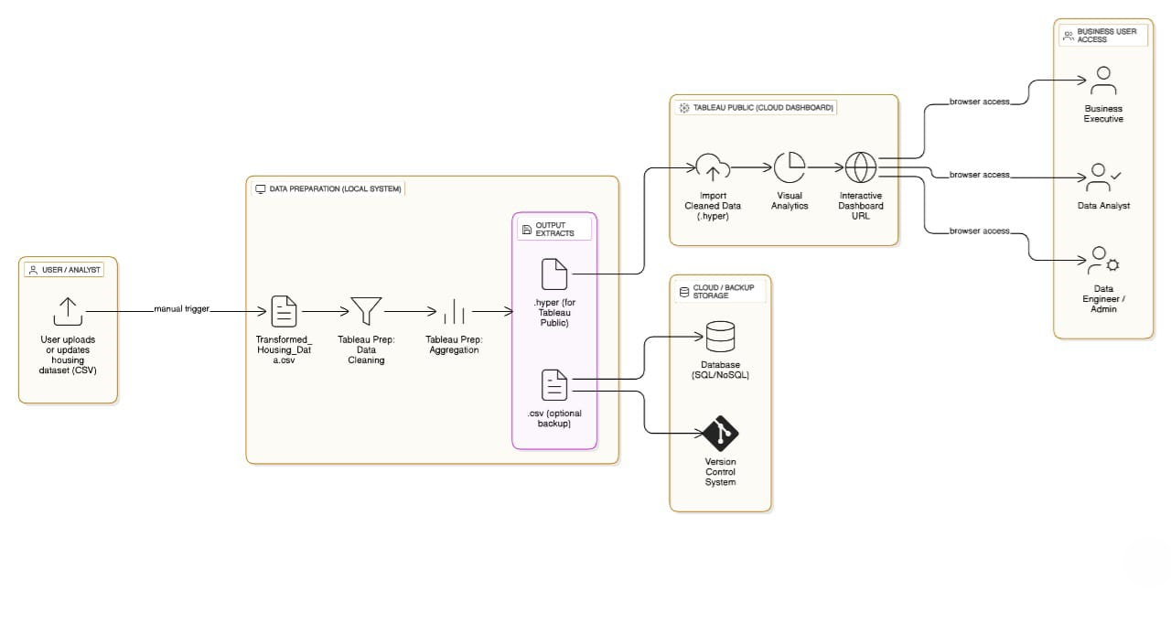
Table-1 : Components & Technologies:
S.No | Component | Description | Technology
1 | User Interface | Final dashboard seen by end users | Tableau Public, HTML, Flask
2 | Data Source | Housing dataset source | Google Drive / Local CSV
3 | Data Collection | Gathering dataset for analysis | Manual / Scripted download
4 | Data Preparation | Cleaning & transformation | Tableau Prep
5 | Data Visualization | Building charts & visuals | Tableau Public Desktop
6 | Dashboard & Story | Visual storytelling with filters | Tableau Story
7 | Web Integration | Embedding dashboards into UI | Flask (Python Web Framework)
8 | Hosting Infrastructure | Hosting the Flask app | Localhost / Web server

Table-2: Application Characteristics:
S.No | Characteristics | Description & Technology
1 | Open-Source Frameworks | Tableau Public, Flask
2 | Security Implementations | Dataset access via local storage or private Tableau links
3 | Scalable Architecture | Layered and modular architecture flow
4 | Availability | Accessible via Tableau Cloud and Flask Web App
5 | Performance | Optimized Tableau dashboards using filters and cache

References:
https://c4model.com/
https://developer.ibm.com/patterns/online-order-processing-system-during-pandemic/
https://www.ibm.com/cloud/architecture
https://aws.amazon.com/architecture
https://medium.com/the-internal-startup/how-to-draw-useful-technical-architecture-diagrams-2d20c9fda90d

